Lab Practical #05:
Develop mobile or web screen using the tools listed below.

Practical Assignment #05:
Use the tools listed below:
Blending Modes, Alignment, & Distribution, Union and Corner Radius, Shadow.

Description:
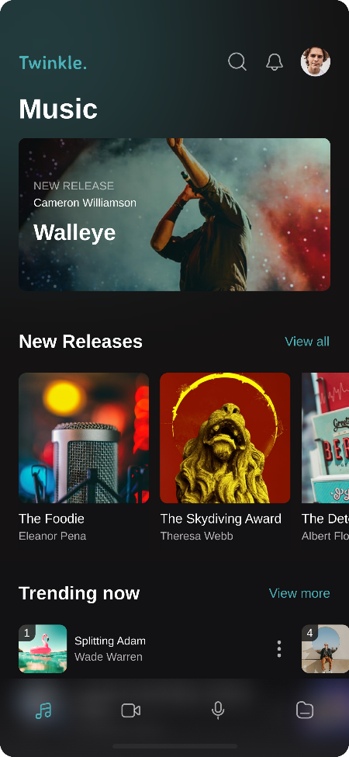

Browse Screen

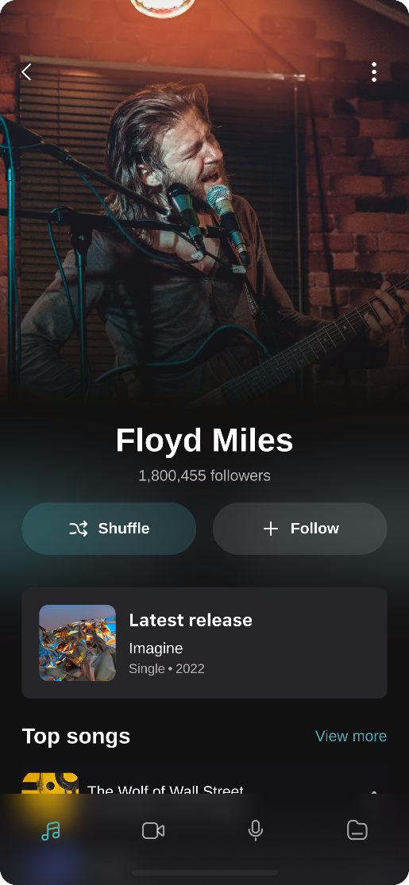

Artist Screen

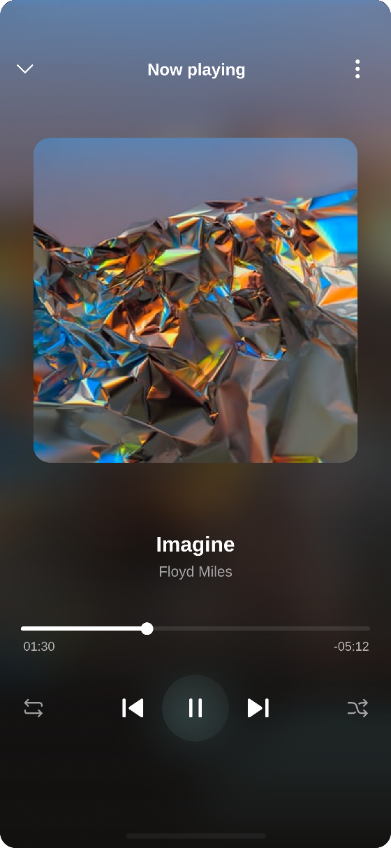

Now Playing Screen

